South Wireless Summit Scholarship Application --Submit to: southwireless2020@gmail.com
(Fall 2021-Award) Deadline for Submission-07-01-21--5 PM EDT
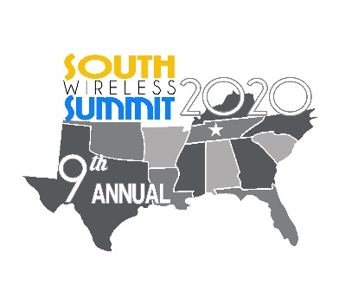

South Wireless Summit Scholarship

ALL APPLICATIONS-Must be submitted to the E-Mail Address above to be Considered!!!
DO NOT MAIL-NO MAILED IN APPLICATIONS WILL BE CONSIDERED. No Late Submissions will be considered or reviewed.

Southwireless2020@gmail.com

State Association (member of): College Planning to Attend/Are Attending:
_________________________________ _____________________________________

AD HOC Applicant(Only): _______________________________________
Member State/School Attending State
Applicant Information
Date:
Applicant Name:
Parent(s) Name:
Street Address:
Mailing Address: (street, City, Zip)
Applicant Email:
Applicant Phone:
Parent(s) Email:
Parent(s) Phone:
Birth Date:
Current Grade:
Graduation Date:
Emergency Contact Name/Number:

High School name and address:

ACT/SAT Test: | Math: |  | Science: |  |  | English: | Reading: |  |  | Cumulative:
Score:
Courses: (High School) ** In Addition---Add College grades below (if already in College)-see Matrix-next Matrix Down:
Course Name (Algebra II, Biology II, etc.): |  | Sophomore Grades: |  |  |  | Junior Grades: |  |  | Senior Grades:
GPA Information: (4.0 Scale)-For High School
Science GPA Cumulative |  |  | Electives GPA Cumulative |  |  |  | Art/Drama GPA Cumulative
History GPA Cumulative |  |  | Foreign Language GPA Cumulative |  |  |  | Music/Band/Choir GPA Cumulative
English GPA Cumulative |  |  | PE/Athletics GPA Cumulative |  |  |  | Cumulative GPA Grade 9-12
Attach to this Form: **Official High School Transcript**
**ACT Scores**-(Substitute SAT Scores if no ACT Scores)
**College Transcript(if applicable)**
COLLEGE GRADES: GPA to be Listed by Each Term and Final GPA for the Term and Cumulative GPA

COURSE | Semester/Qtr. Taken | GRADE | CUMULATIVE GPA/TERM
Cumulative GPA | END of FALL 2019: |  | ________________________

Work History
Company Name |  |  |  | Address |  |  |  | Dates of Employment

Extra Curricular Activities: (Volunteer work, Charitable Activity, Sports outside of School, Tutoring, Mentoring, etc.)
1.
2.
3.
4.
5.
6.
7.
8.

**(Attach required essay to the submitted email)**

ESSAY-Needs to be a Separate saved Document and sent as a separate file and the File labeled as such.

- ESSAY Subject- “The impact of the COVID‐19 pandemic on regular life across the world has changed students use of technology. How has your use of technology changed both in education and in your personal life during the pandemic?”

ESSAY Title:____________________________________________ # of Pages________

Immediate Family Member(s) Wireless Company Name and Job Title
______________________/__________________________
Relation to Applicant:_______________________________
State Association Member:________________________________
(must declare the State that you live in)

****ALL ATTACHMENTS MUST BE PRINTABLE AND SCALABLE*****

By Signing Below-Scholarship Candidate is attesting that all the information is current and accurate. That all attachments are scalable, legible, and the Essay is labeled correctly, as a separate file and that the application will be emailed to the listed email address in accordance with the SPRING, 2020 Scholarship Guidelines.

Signature:_______________________________________________

Print Name: _____________________________________________

Date: ________________________________________________

Signing this Application-Indicates: That you have read the South Wireless Scholarship Guidelines completely; that all your information is accurate; all Lines/Blanks of the Application and information is complete; that you have attached the current transcript-for both High School and College, ACT/SAT Scores, and the Spring 2020 Essay written on the topic detailed above.

