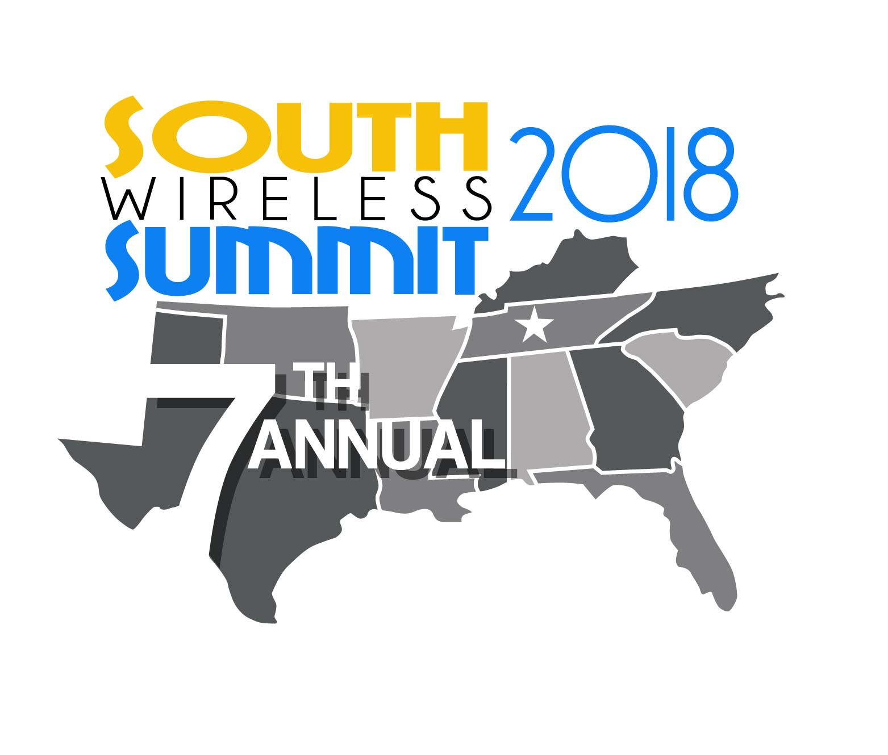

South Wireless Scholarship Fund-Guidelines
FALL-2018

The South Wireless Associations are now accepting applications for the 2018 Fall semester scholarship fund. The scholarship committee will award (1) student in each of the 10 state associations and will receive a grant for the Fall 2018 semester.

Eligibilities include:
- The student must be enrolled full-time in his/her graduate or undergraduate studies at an accredited College or University.
- The student’s family member must be a member of one of the South Wireless Associations: Georgia, Tennessee, Kentucky, Arkansas-Oklahoma, Florida, Louisiana, Mississippi, Alabama, Texas or Carolinas and live in the state that the awarded scholarship Association is awarded.
- The student must have and maintain a 3.0 GPA average in High school and College and must maintain the 3.0 GPA to remain eligible and have received a 23 score or better on the ACT.
- Each State’s Association will award the Scholarship to a Prospective Student in their State.
- AD HOC Scholarship-This Semester-One Scholarship, in addition to the 10 State Scholarships- will be awarded to a Resident of a South Wireless Association State that is a member that will be attending an Accredited University in another State that comprises one of the States that make up the South Wireless Association (NC, SC, GA, FL, AL, MS, LA, OK, AR, TN, KY, TX).
e.g.: An Alabama Resident that will be attending Vanderbilt in Nashville; a Georgia Resident attending Duke University in Durham, etc. You must denote that you are applying as an AD HOC Candidate on your Application.
- The Remaining 10 Scholarships Require that -The student must attend school in the state in which the scholarship is awarded. The Student must be resident of the State that awards the Scholarship, i.e. Texas Scholarship will go to a Texas resident who attends an Accredited Texas University. Past recipients of the Spring, 2018 SWS Scholarship, must have maintained a minimum of a 3.0 GPA to reapply.
- Previous Award Recipients are encouraged to apply.
- This Scholarship is for Fall, 2018 ONLY, the candidate must be enrolled in an accredited University or College-Full time for Fall, 2018 to be eligible for the Fall, 2018 Scholarship. Winning the Fall, 2018 scholarship is a stand-alone award, and the South Wireless Association will award all future scholarships on a Bi-Annual Basis.

Application:
- Once the student has met the criteria above, an Essay must be submitted:Title and Subject: “Mergers: Over the years, there have been many possible mergers proposed – T-Mobile and AT&T, Sprint and T-Mobile, and so on. What are the pros and cons to carrier’s merging and how do you think a merger would impact the telecommunications sector?”
- Applicants will then be vetted and Candidates may be interviewed during the selection process.
- Applications and all the required attachments must be submitted to the following e-mail box: southwireless2018@gmail.com by 5 PM EDT –June 21, 2018 . No mailed in Applications will be considered. All the Scanned documents must be legible and easily printed. All scanned items must be scaled and formatted to an 8” x 11” paper size.
- Only COMPLETE Applications will be reviewed and considered (do not use the phrase-“see transcript or see ACT scores”, all blanks must be filled out on the application). No applicant will be considered if they do not fill out the application entirely and all attachments are submitted with the application! These Attachments must be printable and scalable! ( NO exceptions-if your application cannot be viewed upon receipt, it will be disqualified). If your application is not complete and does not include all attachments and the Essay at the time of submittal, if will be deemed void and not considered.
- If you do not meet the Minimum Qualifications-your application will not be considered.
- The selected candidates of the individual state scholarships will be notified by the committee during July, 2018. All documents sent to the selected candidate must be filled out and returned to the SWS Scholarship Committee for the funds to be distributed to the selected candidate and their University or Institution.

THE DEADLINE TO SUBMIT APPLICATIONS IS THURSDAY, June 21, 2018 at 5 PM-EDT.

