South Wireless Summit Scholarship Application --Submit to: southwireless2018@gmail.com
(Fall 2018-Award) Deadline for Submission-06-21-18--5 PM EDT
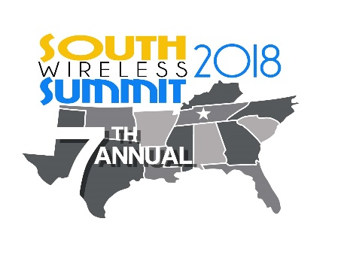

South Wireless Summit Scholarship

ALL APPLICATIONS-Must be submitted to the E-Mail Address above to be Considered!!!
DO NOT MAIL-NO MAILED IN APPLICATIONS WILL BE CONSIDERED.

Southwireless2018@gmail.com

State Association(member of): College Planning to Attend/Are Attending:
_________________________________ _____________________________________

AD HOC Applicant(Only): _______________________________________
Member State/School Attending State
Applicant Information
Date:
Applicant Name:
Parent(s) Name:
Street Address:
Mailing Address: (street, City, Zip)
Applicant Email:
Applicant Phone:
Parent(s) Email:
Parent(s) Phone:
Birth Date:
Current Grade:
Graduation Date:
Emergency Contact Name/Number:
High School name and address:

ACT/SAT Test: | Math: |  | Science: |  |  | English: | Reading: |  |  | Cumulative:
Score:
Courses: (High School) ** In Addition---Add College grades below (if already in College)-see Matrix-next Matrix Down:
Course Name (Algebra II, Biology II, etc.): |  | Sophomore Grades: |  |  |  | Junior Grades: |  |  | Senior Grades:
GPA Information: (4.0 Scale)-For High School
Science GPA Cumulative |  |  | Electives GPA Cumulative |  |  |  | Art/Drama GPA Cumulative
History GPA Cumulative |  |  | Foreign Language GPA Cumulative |  |  |  | Music/Band/Choir GPA Cumulative
English GPA Cumulative |  |  | PE/Athletics GPA Cumulative |  |  |  | Cumulative GPA Grade 9-12
Attach to this Form: **Official High School Transcript**
**ACT Scores**-(Substitute SAT Scores if no ACT Scores)
**College Transcript(if applicable)**
COLLEGE GRADES: GPA to be Listed by Term and Final GPA

COURSE | Semester/Qtr. Taken | GRADE | CUMULATIVE GPA/TERM
Cumulative GPA | END of SPRING 2018: |  | ________________________

Work History
Company Name |  |  |  | Address |  |  |  | Dates of Employment

Extra Curricular Activities: (Volunteer work, Charitable Activity, Sports outside of School, Tutoring, Mentoring, etc.)
1.
2.
3.
4.
5.
6.
7.
8.

**(Attach required essay to the submitted email)**

ESSAY-Needs to be a Separate saved Document and sent as a separate file and the File labeled as such.

- ESSAY Subject- “Mergers: Over the years, there have been many possible mergers proposed – T-Mobile and AT&T, Sprint and T-Mobile, and so on. What are the pros and cons to carrier’s merging and how do you think a merger would impact the telecommunications sector?”

ESSAY Title:____________________________________________ # of Pages________

Immediate Family Member(s) Wireless Company Name and Job Title
______________________/__________________________
Relation to Applicant:_______________________________
State Association Member:________________________________
(must declare the State that you live in)

****ALL ATTACHMENTS MUST BE PRINTABLE AND SCALABLE*****

By Signing Below-Scholarship Candidate is attesting that all the information is current and accurate. That all attachments are scalable, legible, and the Essay is labeled correctly, as a separate file and that the application will be emailed to the listed email address in accordance with the FALL, 2018 Scholarship Guidelines.

Signature:_______________________________________________

Print Name: _____________________________________________

Date: ________________________________________________

Signing this Application-Indicates: That you have read the South Wireless Scholarship Guidelines completely; that all your information is accurate; all Lines/Blanks of the Application and information is complete; that you have attached the current transcript-for both High School and College, ACT/SAT Scores, and the FALL 2018 Essay written on the topic detailed above.

